**Marketplace Technical Foundation PizzaStreet:**

1. **System Architecture:**

PizzaStreet is a Q-commerce platform focusing on real-time inventory updates, delivery SLA tracking and order workflow. Below is the architecture:

**System Components**

* **Frontend (Next.js):** Used for browsing products, placing orders, and tracking delivery.
* **Sanity CMS:** Backend for managing product data, customer details, order records, and delivery zones.
* **Third-Party APIs**: Handles shipment tracking, payment processing, and notifications.

1. **Architecture Diagram**

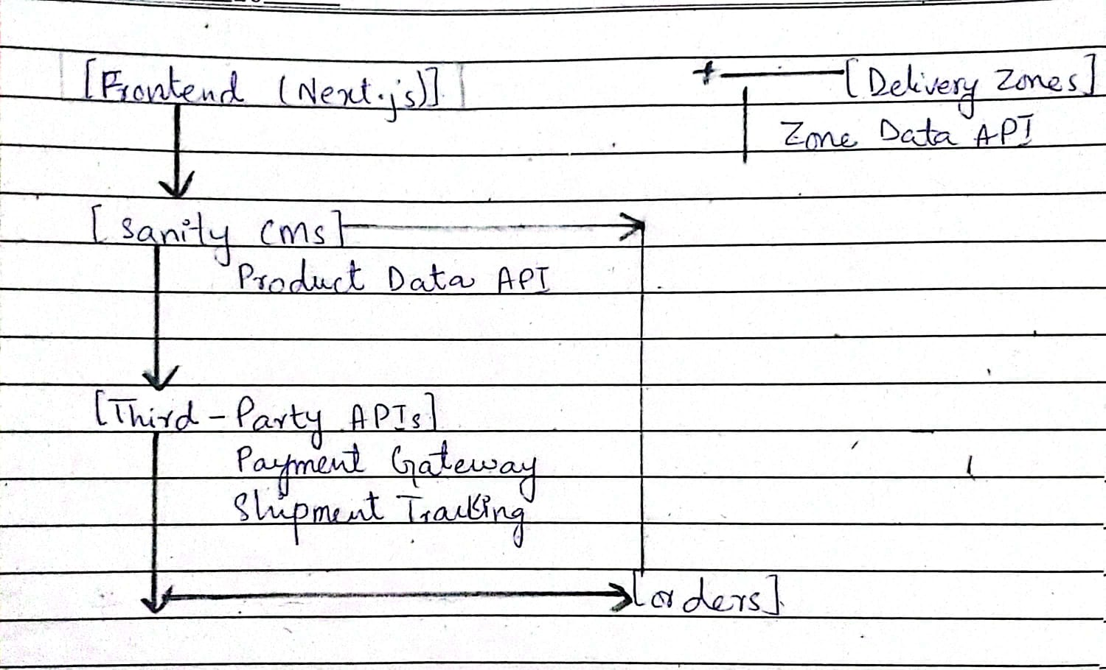

* + **Component Roles:**
* **Frontend:** Provides user interaction and dynamic content rendering.
* **Sanity CMS:** Manages and stores core data such as products, orders, users, and delivery zones.
* **Third-Party APIs:** Ensures reliable payment and shipment tracking services.

* + **Interaction Diagram**:

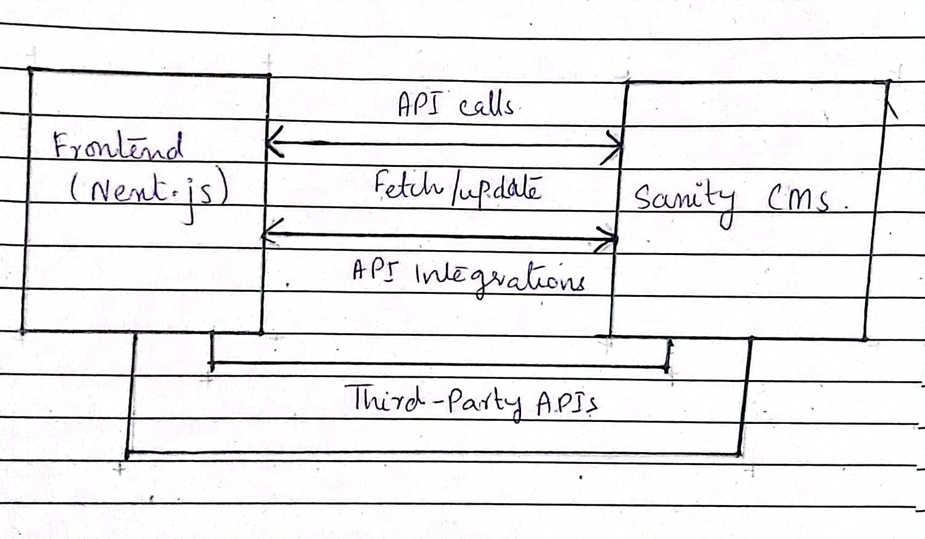

1. **Key Workflows to Q-Commerce:**
2. **Real-Time Inventory Updates**

* User browses products on the fronted.
* Fronted queries Sanity CMS to fetch the latest product stock levels.
* Sanity CMS responds with updated inventory details.
* Fronted dynamically updates product availability in real-time.

1. **SLA Tracking**

* User places an order through the fronted.
* Order details, including delivery zone and timing, are sent to Sanity CMS.
* Sanity CMS triggers a query to the shipment tracking API to calculate SLA( Service Level Agreement) timelines.
* SLA data is sent back to the fronted and displayed to the user.

1. **API Endpoints:**

|  |  |  |  |  |
| --- | --- | --- | --- | --- |
| **Endpoints** | **Method** | **Description** | **Payload** | **Response** |
| /Products | Get | Fetch all available product from Sanity | N/A | { "id": 1, "name": "Product A", "price": 100, "stock": 20 } |
| /Order | Post | Create a new order in Sanity. | {"userId": 123, "products": [{ "productId": 1, "quantity": 2 }], "totalPrice":200, "deliveryZoneId":1  } | {"orderId":456, "status":"Pending" } |
| /Shipment | Get | Track order status via Third-party API | N/A | {"shipmentId":789, "orderId": 456, "status":"In Transit",  "eta": "15 mins" } |

1. **Sanity Schema Design:**
   1. **Product Schema**

Export default {

Name: ‘product’,

Type: ‘document’,

Fields: [

{ name: ‘name’, type: ‘string’, title: ‘Product Name’ },

{ name: ‘description’, type: ‘text’, title: ‘Description’ },

{ name: ‘category’, type: ‘string’, title: ‘Category’ },

{ name: ‘price’, type: ‘number’, title: ‘Price’ },

{ name: ‘stock’, type: ‘number’, title: ‘Stock Level’ }

]

};

* 1. **Delivery Zones Schema**

Export default {

Name: ‘deliveryZone’,

Type: ‘document’,

Fields: [

{ name: ‘zoneName’, type: ‘string’, title: ‘Zone Name’ },

{ name: ‘coverageArea’, type: ‘string’, title: ‘Coverage Area’ },

{ name: ‘assignedDrivers’, type: ‘array’, of: [{ type: ‘reference’, to: [{ type: ‘deliveryDriver’ }] }], title: ‘Assigned Drivers’ }

]};

* 1. **Orders Schema**

Export default {

Name: ‘order’,

Type: ‘document’,

Fields: [

{ name: ‘userId’, type: ‘reference’, to: [{ type: ‘user’ }], title: ‘User ID’ },

{ name: ‘totalPrice’, type: ‘number’, title: ‘Total Price’ },

{ name: ‘paymentId’, type: ‘string’, title: ‘Payment ID’ },

{ name: ‘deliveryZoneId’, type: ‘reference’, to: [{ type: ‘deliveryZone’ }], title: ‘Delivery Zone ID’ },

{ name: ‘status’, type: ‘string’, title: ‘Order Status’ },

{ name: ‘orderDate’, type: ‘datetime’, title: ‘Order Date’ },

{ name: ‘deliveryDate’, type: ‘datetime’, title: ‘Delivery Date’ }

]};

* 1. **Order Items Schema**

Export default {

Name: ‘orderItem’,

Type: ‘document’,

Fields: [

{ name: ‘orderId’, type: ‘reference’, to: [{ type: ‘order’ }], title: ‘Order ID’ },

{ name: ‘productId’, type: ‘reference’, to: [{ type: ‘product’ }], title: ‘Product ID’ },

{ name: ‘quantity’, type: ‘number’, title: ‘Quantity’ },

{ name: ‘pricePerItem’, type: ‘number’, title: ‘Price Per Item’ }

]}

* 1. **Payments Schema**

Export default {

Name: ‘payment’,

Type: ‘document’,

Fields: [

{ name: ‘orderId’, type: ‘reference’, to: [{ type: ‘order’ }], title: ‘Order ID’ },

{ name: ‘paymentMethod’, type: ‘string’, title: ‘Payment Method’ },

{ name: ‘paymentStatus’, type: ‘string’, title: ‘Payment Status’ },

{ name: ‘paymentDate’, type: ‘datetime’, title: ‘Payment Date’ },

{ name: ‘transactionId’, type: ‘string’, title: ‘Transaction ID’ }

]};

6. **User Schema**

Export default {

Name: ‘user’,

Type: ‘document’,

Fields: [

{ name: ‘name’, type: ‘string’, title: ‘Name’ },

{ name: ‘email’, type: ‘string’, title: ‘Email’ },

{ name: ‘phoneNumber’, type: ‘string’, title: ‘Phone Number’ },

{ name: ‘address’, type: ‘string’, title: ‘Address’ }

]};

7. **Delivery Drivers Schema**

Export default {

Name: ‘deliveryDriver’,

Type: ‘document’,

Fields: [

{ name: ‘name’, type: ‘string’, title: ‘Name’ },

{ name: ‘contactInfo’, type: ‘string’, title: ‘Contact Info’ },

{ name: ‘assignedZoneId’, type: ‘reference’, to: [{ type: ‘deliveryZone’ }], title: ‘Assigned Zone ID’ },

{ name: ‘vehicleInfo’, type: ‘string’, title: ‘Vehicle Info’ }

]};